# Reexam 2023

Indholdsfortegnelse

Reexam 2023 1

Problem 1. Time shift / reversal / Scaling to create and show x. ( 18 % ) 2

Problem 2. Convolution √ ( 20 % ) 7

Problem 3. Fourier transform √ ( 20 % ) 9

Problem 4. Fourier transform √ ( Mangler phase udtryk til sidst ) ( 17,5 % ) 10

Problem 5. Modulation ( 5 % ) 12

## Problem 1. Time shift / reversal / Scaling to create and show x. ( 18 % )

Formel: Graf:

*Ligningen løses for a vha. WordMat.*

So it fits due to its symmetri.

Now the second I will scale by a factor of two.

Now for shifting.

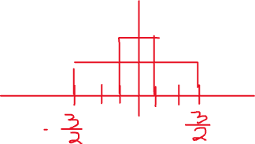

Den aktivere fra .

Skal være aktiv for t = 0 i den første.

================================  
   
   
   
================================

Now for the smaller rectangle.

*Ligningen løses for t_0 vha. WordMat.*

=================  
   
   
   
=================

1. Determine Periodicity. If it is, what’s its

The sinus signal is in continuous time. That means, it means, that it undergoes infinite amount of values.   
It’s own period can be found at:



Is only periodic for being an integer.

There exist no m such that n is an integer, due to irrationality.



Is a decaying function, and will never be periodic.

**Which is periodic?**================   
   
   
   
================

1. Et billede, der indeholder tekst, Font/skrifttype, hvid, linje/række

   Automatisk genereret beskrivelseDetermine whether the following system is memoryless, causal, time invariant and / or linear

Time invariant:   
If the signal is supposed to be time invariant, a change in time in the input wouldn’t mean a different change in time at the output.

If , then time invariancy is true.

√  
And so the input is time invariant.

Memoryless:   
Does it store values for times other than ?

If it were, it would only takes values at t, but here it has to remember what , was. And so I would say, that it isn’t memoryless.

Linearity:   
Does a scale at the input equal the same scale at the output?

If then the system is in fact linear.

And so the system is linear.

Causality.

So what I can conclude is that:   
======================  
 is :   
Time invariant √  
Memoryless √  
Linear √  
Causal ?   
======================

## Problem 2. Convolution √ ( 20 % )



1. Sketch h and x.

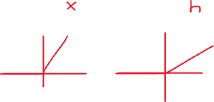

1. Et billede, der indeholder tekst, Font/skrifttype, hvid, linje/række

   Automatisk genereret beskrivelseCompute using the convolution integral

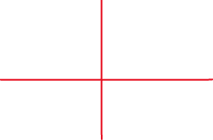

=======  
   
=======

1. 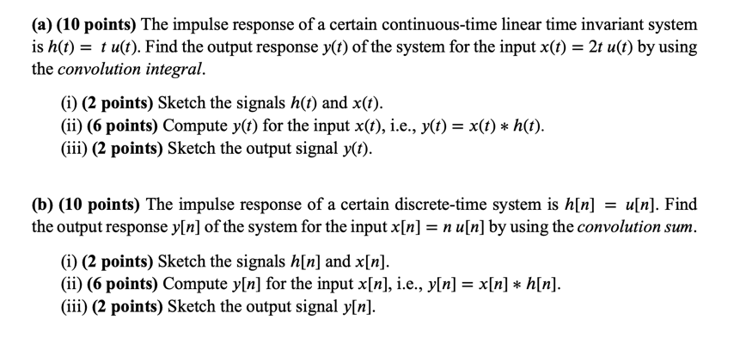Convolution sum.

1. Sketch h and n

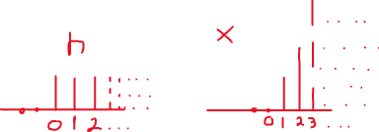

1. Et billede, der indeholder tekst, Font/skrifttype, hvid, linje/række

   Automatisk genereret beskrivelseCompute

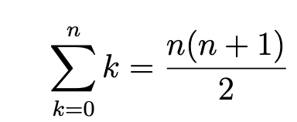Non negative for   
And that’s a finite   
==========  
   
==========

1. Sketch

## Problem 3. Fourier transform √ ( 20 % )

1. Sketch it.



1. 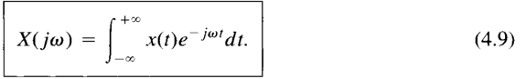Compute the fourier transform using the analysis equation.

==============  
   
==============

1. Udtryk I forhold til magnituden.

===================  
   
===================

1. Et billede, der indeholder linje/række, Kurve, diagram

   Automatisk genereret beskrivelseSketch magnituden.

As expected, the cos/w acts as a sinc function, and the   
 acts as a boost at the start but will become negligible over time. This plot is discrete, as these are in fact at a singularity at 0.

## Problem 4. Fourier transform √ ( Mangler phase udtryk til sidst ) ( 17,5 % )

1. A continous time system:

1. Determine the frequency response.

Using the properties:   
   
   
   
  
I get me response to be:   
   
   
====================  
   
====================

1. Sketch the frequency response.

It makes sense.   
   
A decaying function. Due to interference with the time delayed function, this is the result:



1. A discrete time linear time invariant system.

1. Determine the frequency response

======================  
   
======================

1. 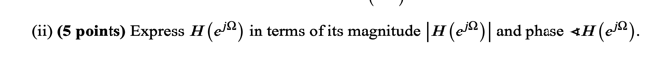Express in terms of magnitude and phase.

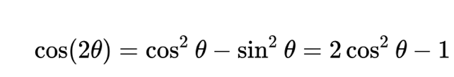   
   
   
  
   
=====================  
   
=====================



## Et billede, der indeholder tekst, Font/skrifttype, skærmbillede, dokument Automatisk genereret beskrivelseProblem 5. Modulation ( 5 % )

1. Consider the signal

Determine the Nyquist rate and the sampling period for the signal   
  
The highest frequency component is .   
   
To ensure no aliasing.   
   
   
   
  
===============  
   
   
===============

1. Consider the signal

If the signal undergoes impulse train sampling to generate

1. Sketch & and the resulting fourier transform of the sampled

Now this is a case of a periodic signal being into aperiodic environments, by finding it’s fourier transform.

Normally I would go finding the fourier series representation , for then doing fourier transform on those with the fourier series - fourier transform relationship.

However, as the sinusoidal signal is made of pure tones, I already has it’s fourier transform pair.

The sampling train is can also just be calculated from the fourier transform pair, but this time it has to be written in another way.